
Program :B.tech(CSE)
Specialization :AIML
Course Title :AI Assisted Coding
Course Code :24CS002PC215
Semester :3rd semester
Academic Session :2025-2026
Name of Student :Bachanagari Deekshitha
Enrollment No. :2403A52032
Batch No. :02
Date :26/08/2025
#LAB ASSIGNMENT
Task Description -1:
- Zero-shot: Prompt AI with only the instruction — Write a Python function to
generate the Fibonacci sequence up to n terms.
#PROMPT:
- Write a python function to generate the Fibonacci sequence up to n terms.
# QUESTION:
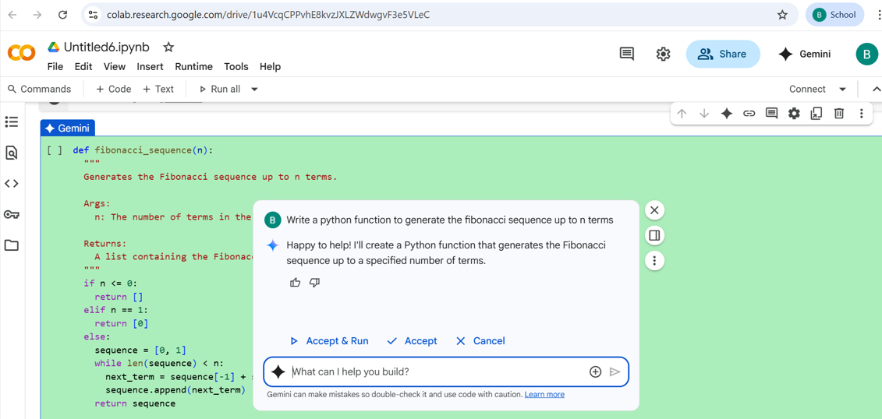
#CODE:
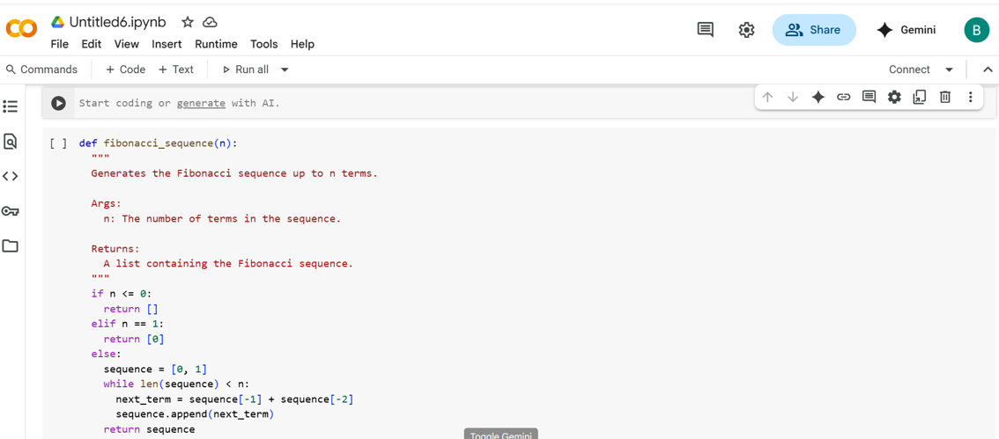
#OUTPUT:
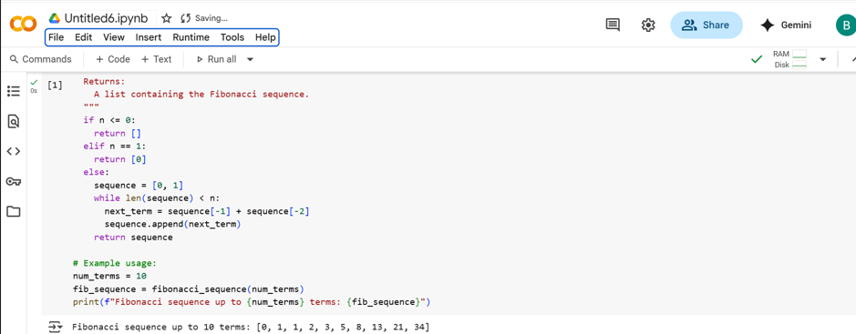

Task Description-2:
- One-shot: Provide one example: Input: 100, Output: 37.78 to help AI generate a
function that converts Fahrenheit to Celsius.
#PROMPT:
- Write a python function that converts Fahrenhit to Celsius with this example

#QUESTION:
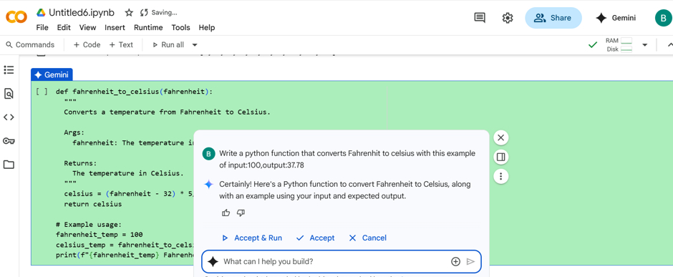
#CODE:
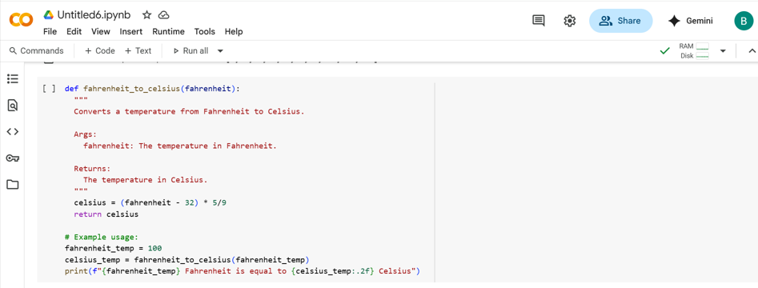
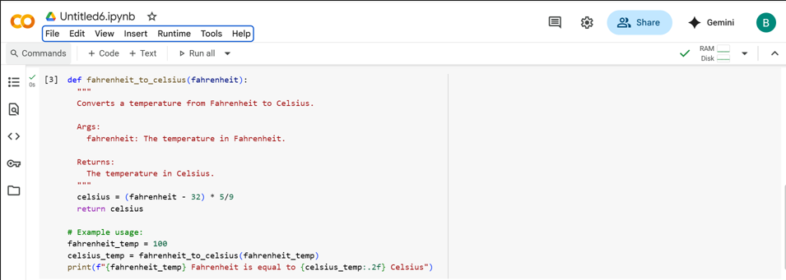
#OUTPUT:
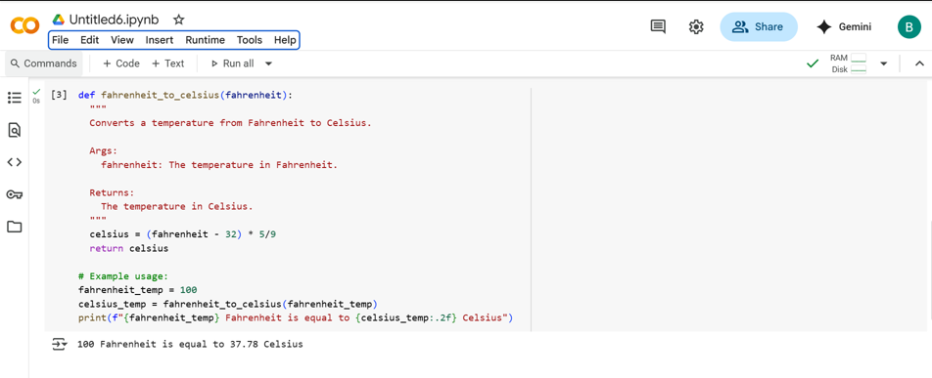
#Task Description:
- Few-shot: Give 2–3 examples to create a function that extracts the domain name from
an email address.
#PROMPT:
- Write a python function extract_domain(email) that returns the domain part of an email address,Give 2-3 eg. For the question.
#QUESTION:
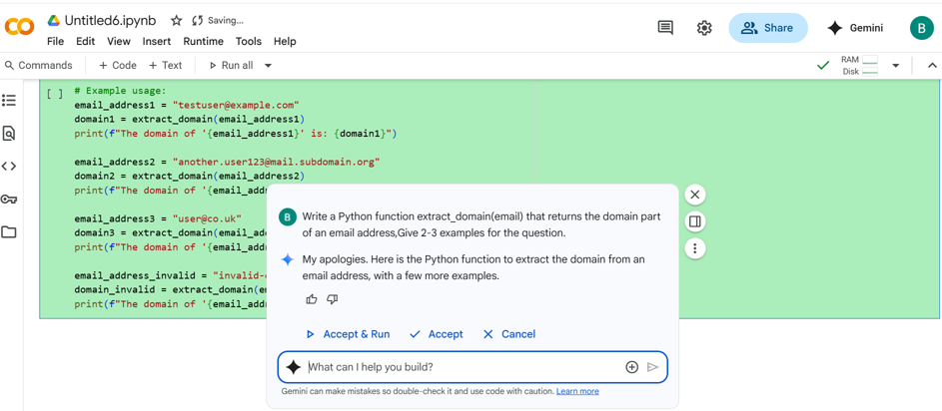
#CODE:
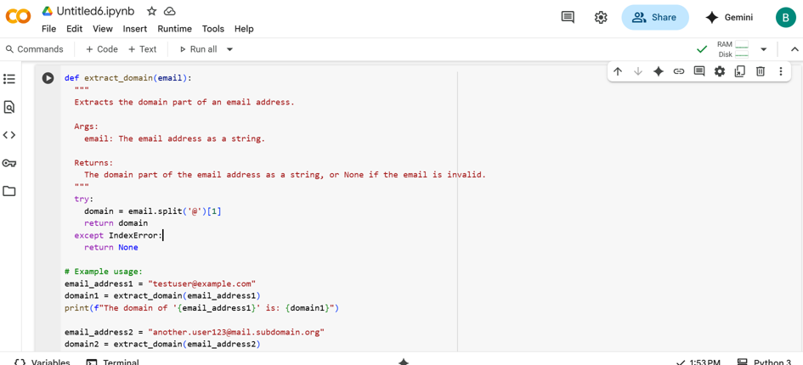
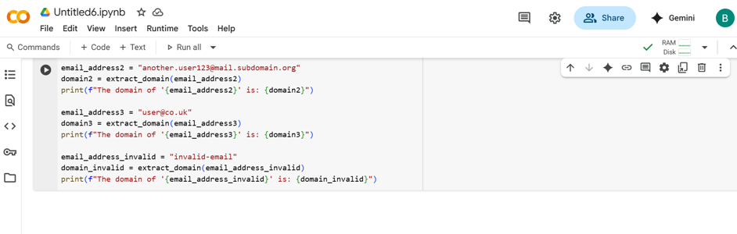
#OUTPUT:
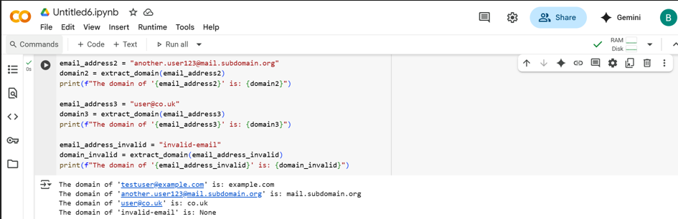

Task Description-3:
- Compare zero-shot vs few-shot prompting for generating a function that checks
whether a word is a palindrome, ignoring punctuation and case.

#PROMPT:
- Compare zero-shot and few-shot prompting for writing a python function that checks if a word is a palindrome,ignoring punctuation and case.show both outputs and explain how examples improve model accurancy.
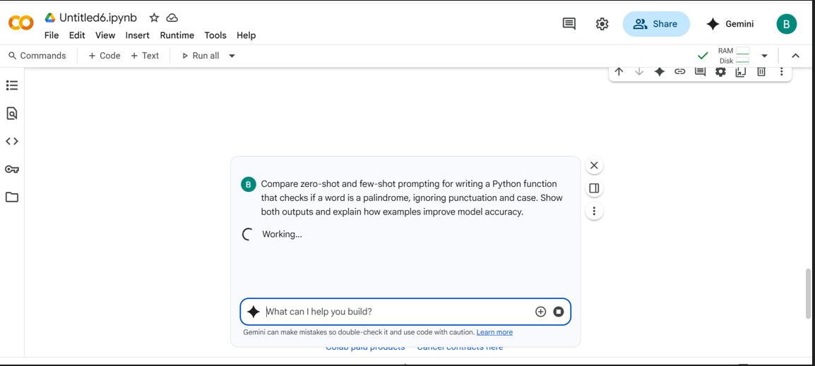

#CODE WITH OUTPUT:
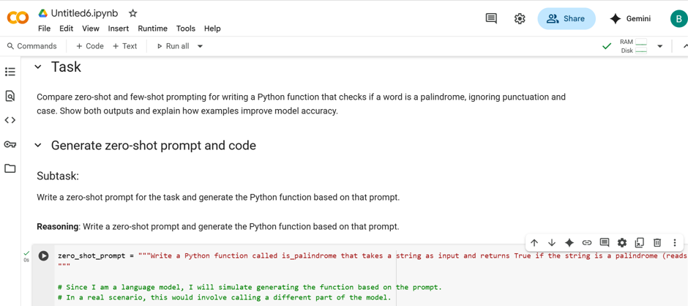
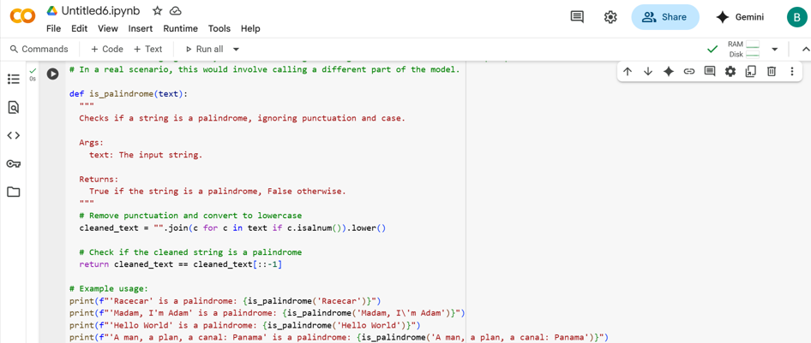
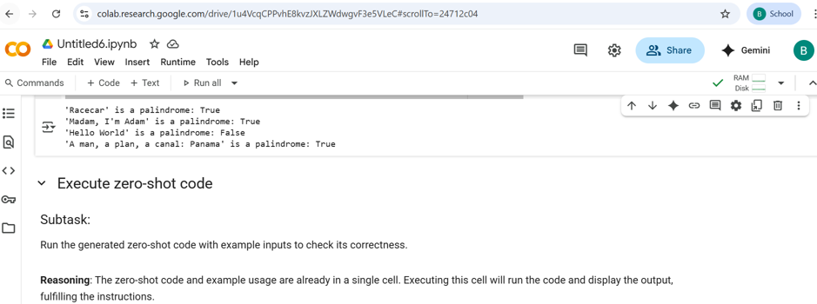
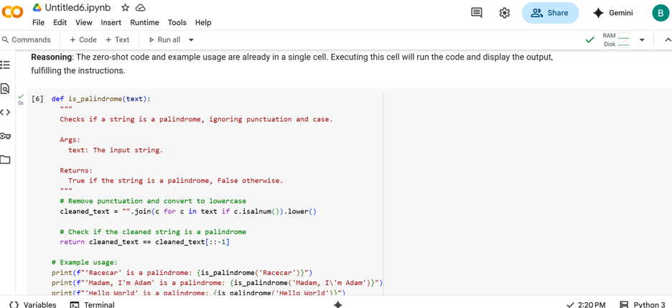
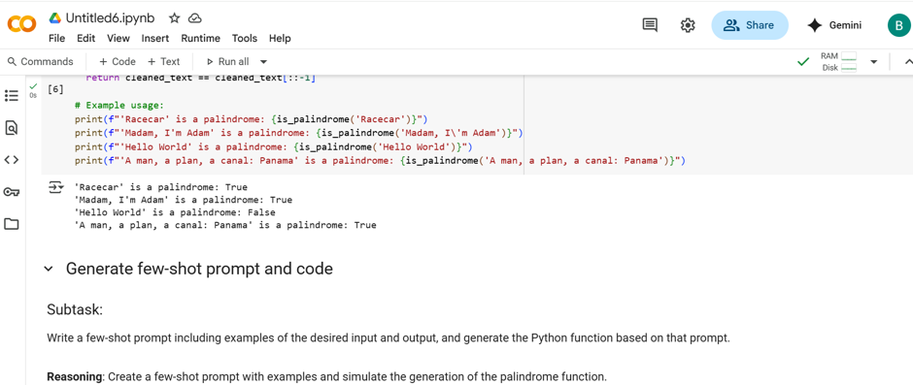
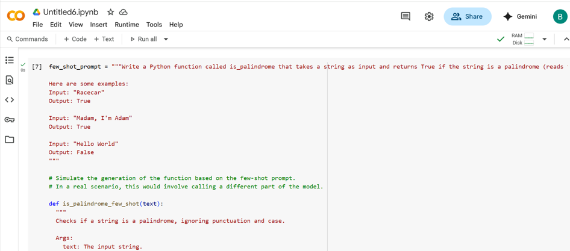
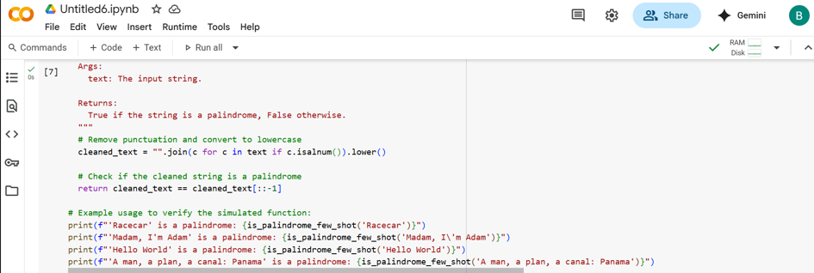
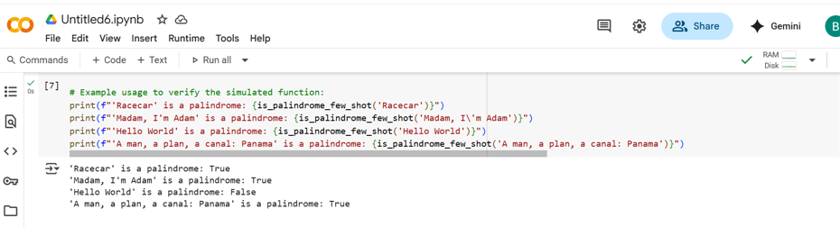
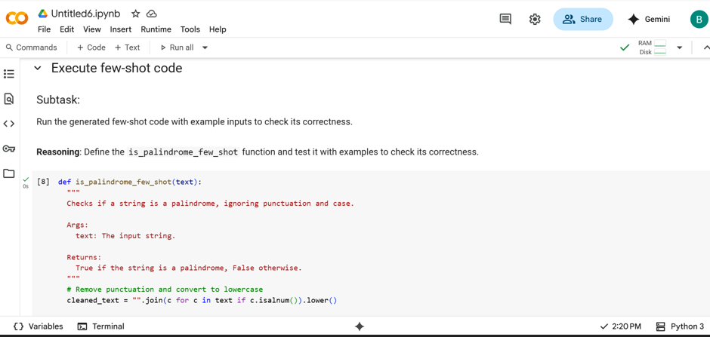
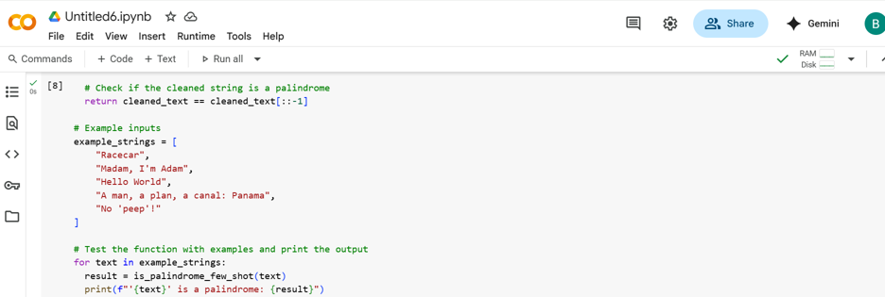
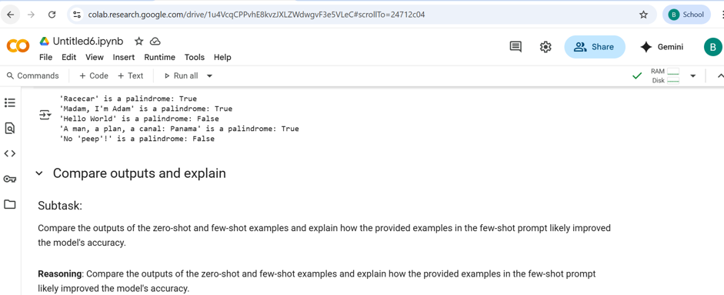
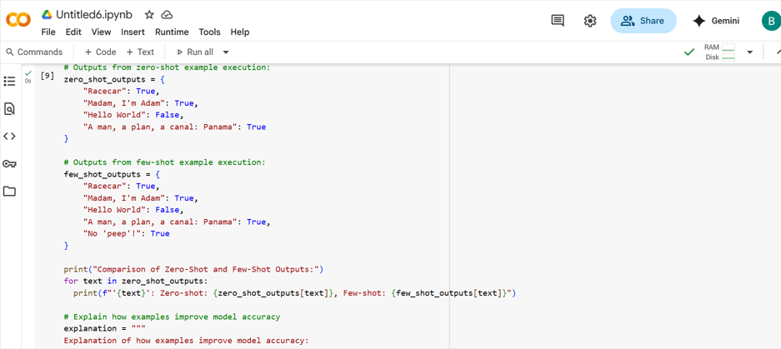
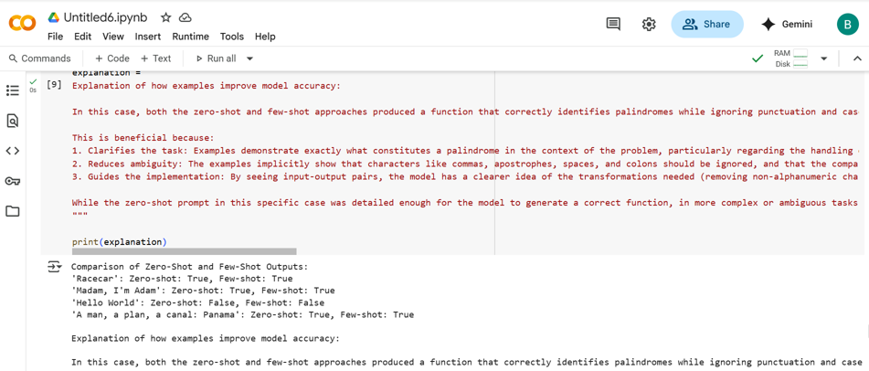
#SUMMERY:
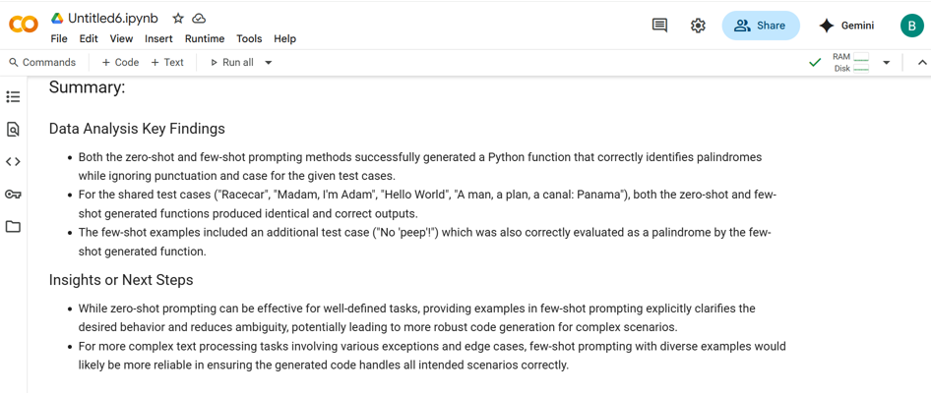
#Task Description-5:
- Use few-shot prompting with 3 sample inputs to generate a function that determines
the maximum of three numbers without using the built-in max() function.
#PROMPT:
- Write a python function find_max(a,b,c) that returns the largest of three numbers without using the built-in max() function. Using with this example find_max(10,25,15), find_max(-5,-10,-3), find_max(7,7,7).
#QUESTION:
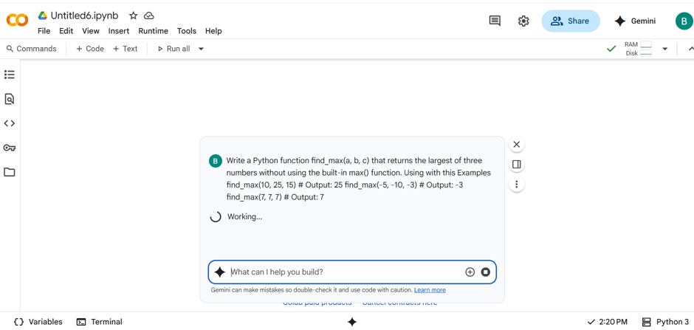
#CODE:
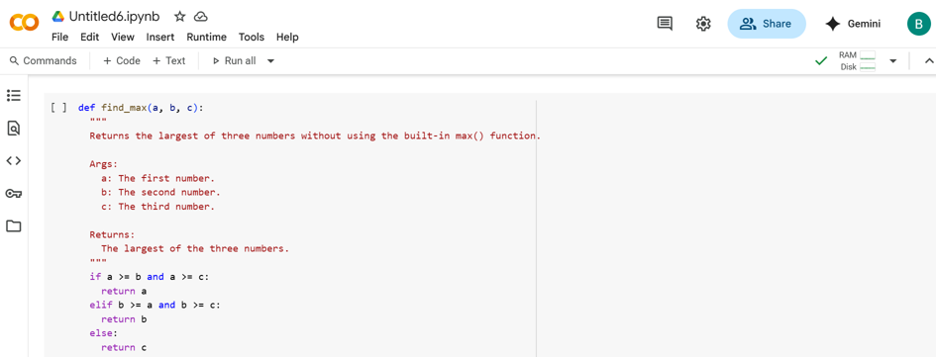
#OUTPUT:
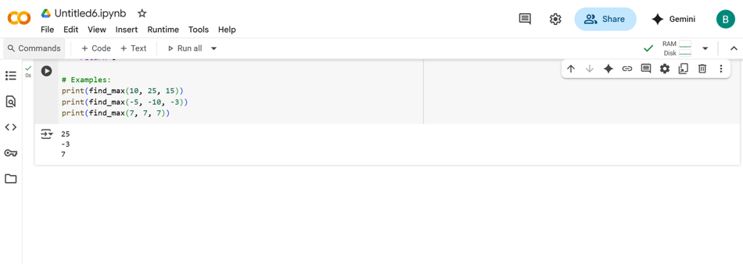
-THANK YOU-

